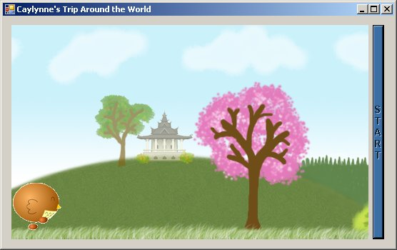

How does teaching students to program animation help them learn math?

Master’s Project on working with students to teach them math through animation

Linae Graupmann
University of Washington Bothell
Masters of Education Program
Fall 2007

