Screenshots of PowerPoint Presentations

Architectural Animations
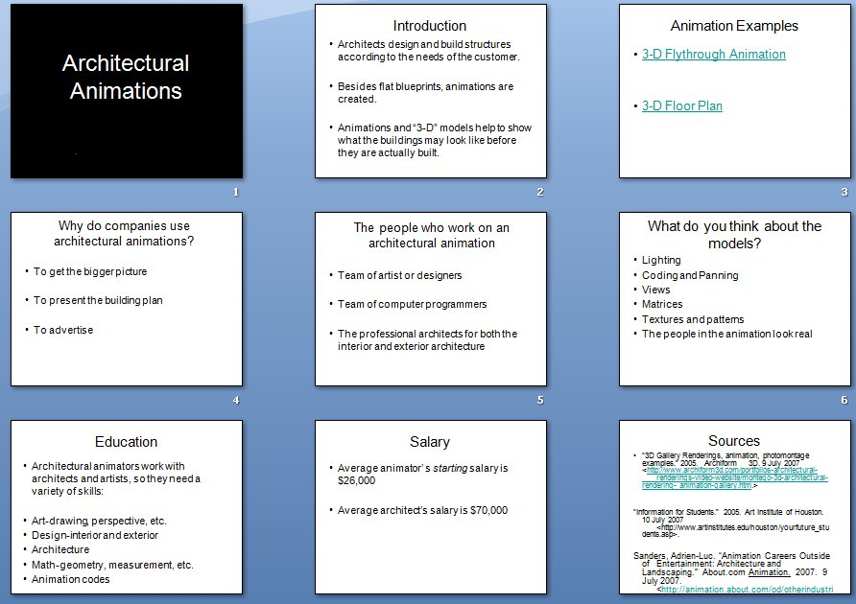
By Student 8, Student 16, & Student 19

Animations in Astronomy
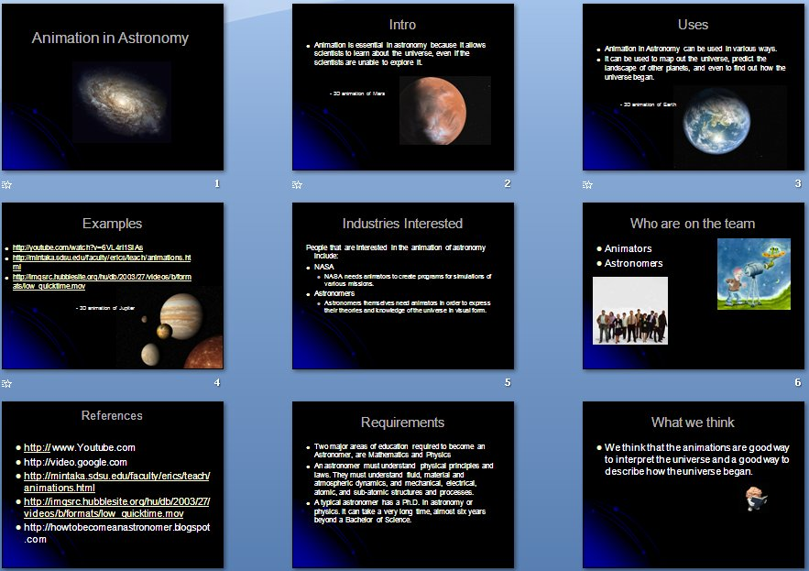
By Student 18 & Student 6

Animation for Education
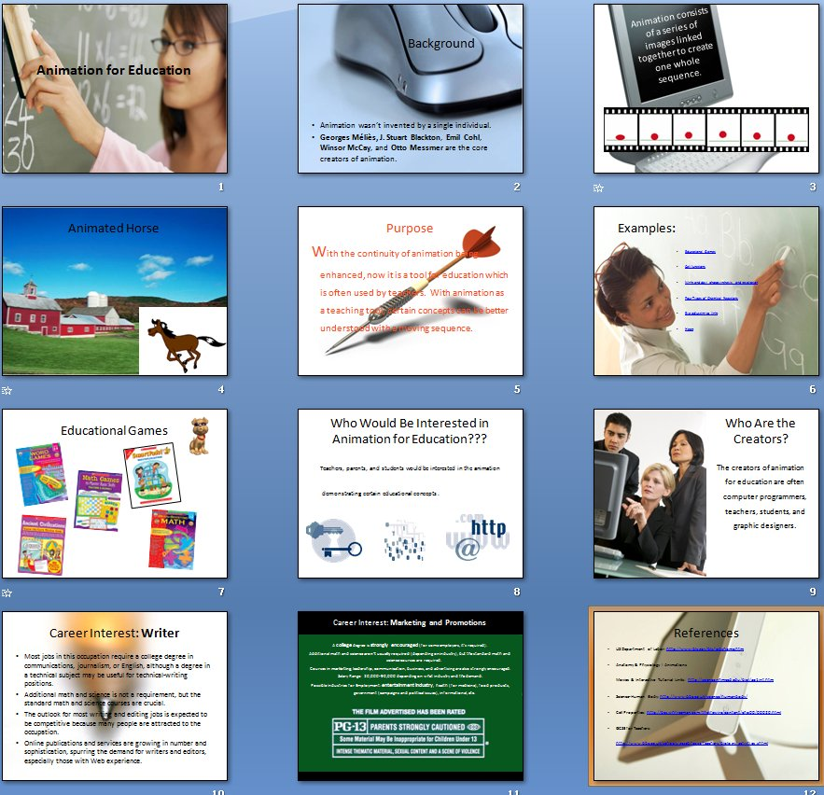
By Student 10 & Student 24

Mechanical Engineering in NASA
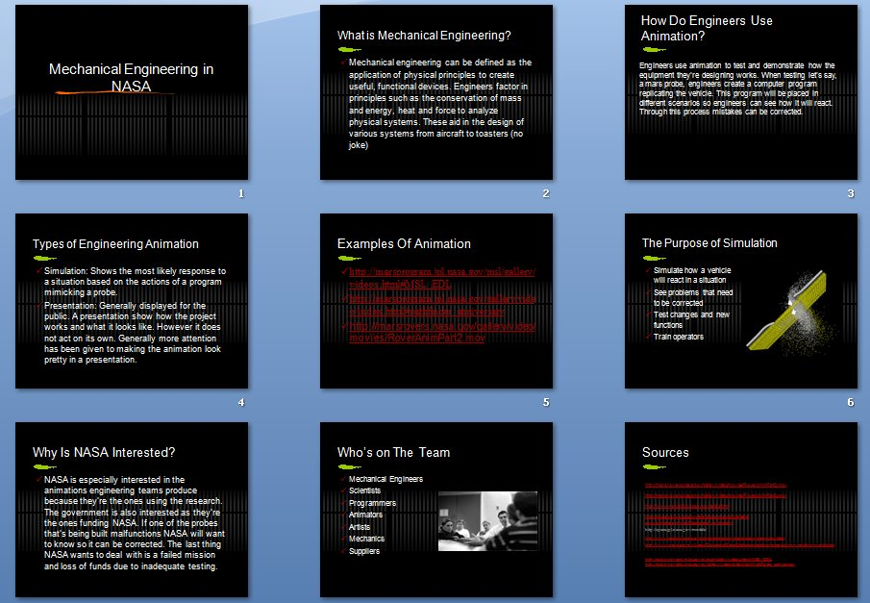

Forecasting Natural Disasters
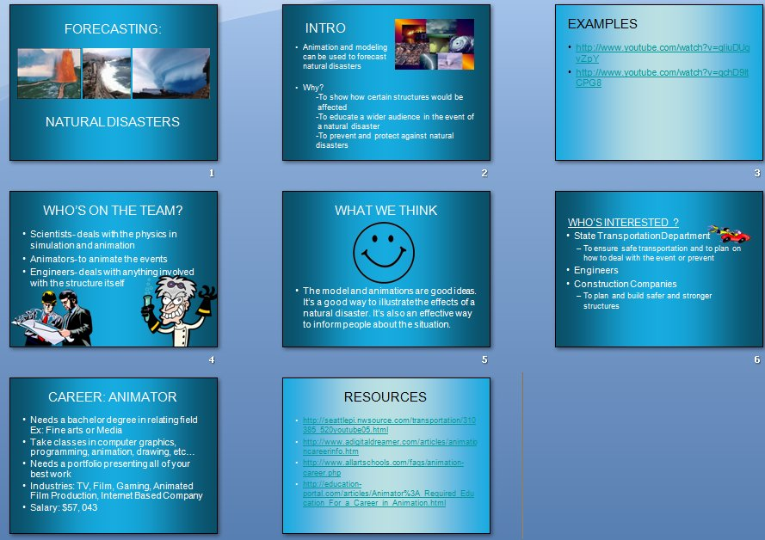

Global Warming
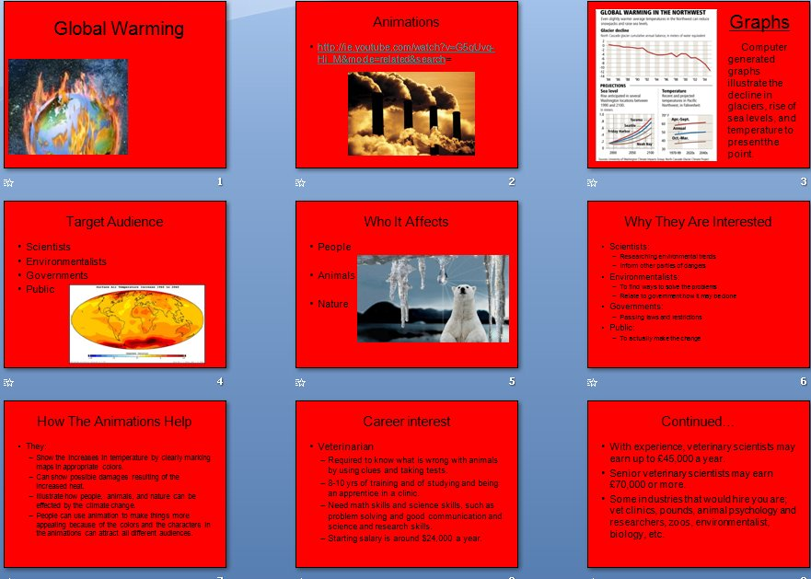
By Student 12 & Student 3

Pilot Training
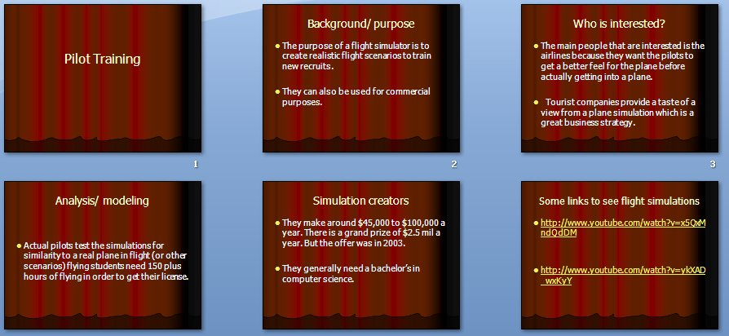
By Student 2 & Student 23

Roller Coasters
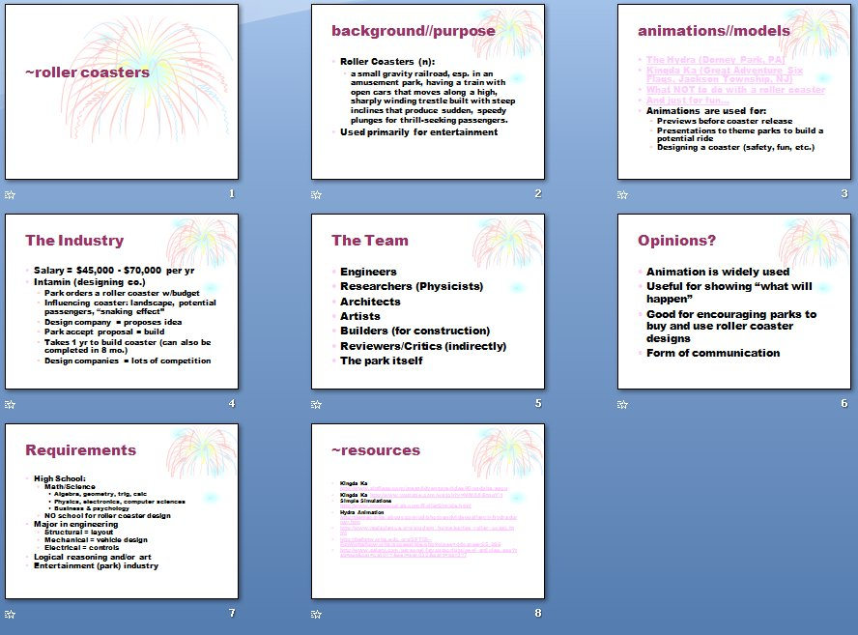
By Student 1, Student 11, & Student 17

Simulations for Training Astronauts
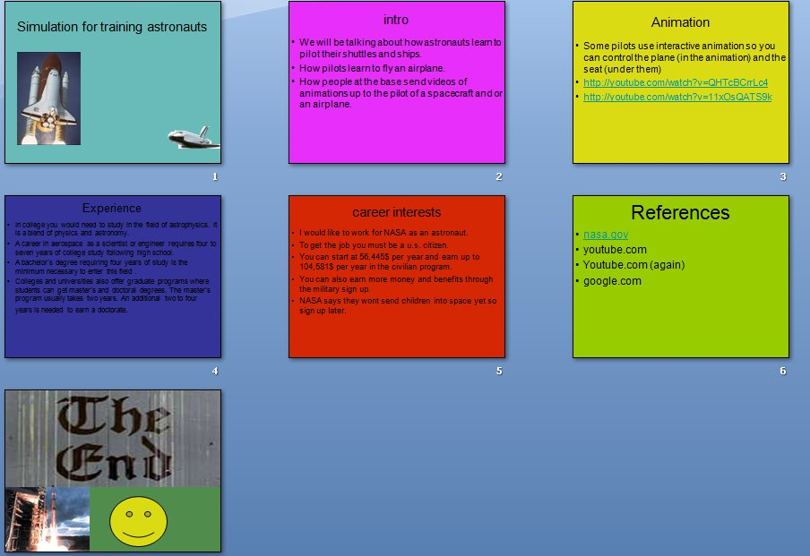
By Student 15 & Student 20

