Screenshots of Final Animation Projects

Student 1
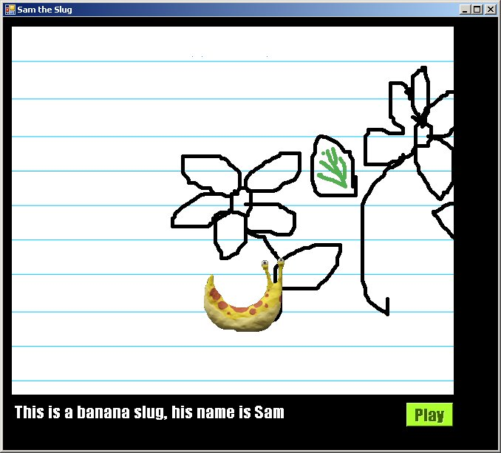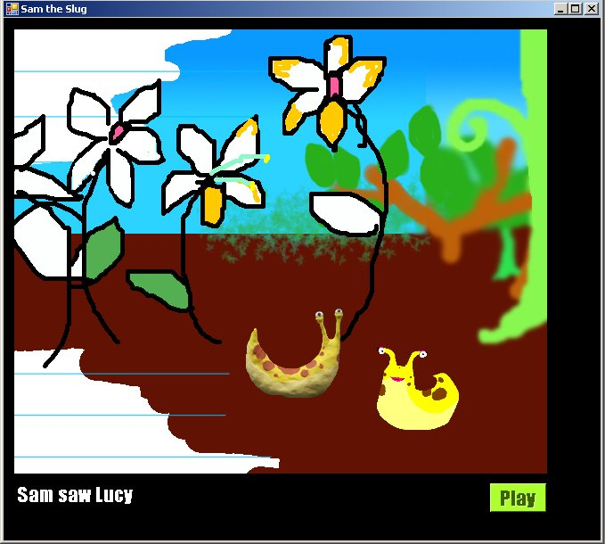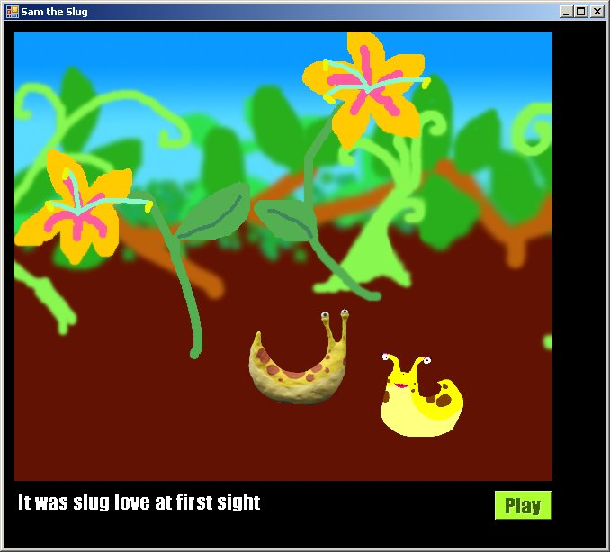
Sam the slug is stuck in 2D and then by some quirk is transported into 3D with color and Lucy the slug. The background scrolls left while Sam remains in middle of screen. A clay animation was used for Sam the slug. The background was drawn with Photoshop. The animation has wind sound effect.

Student 2
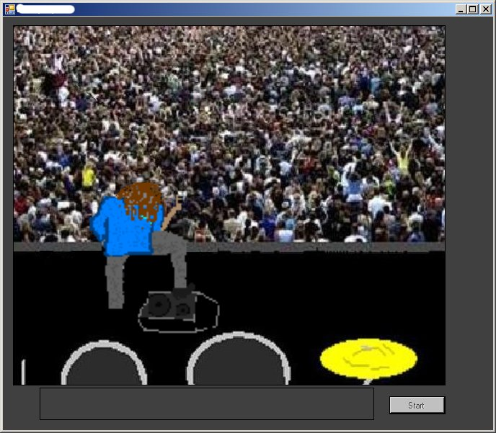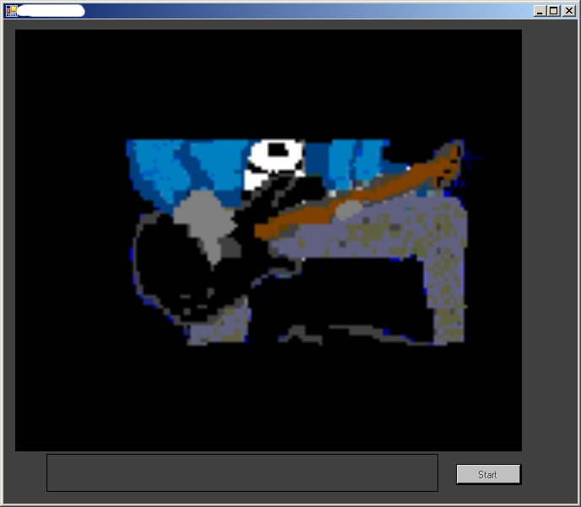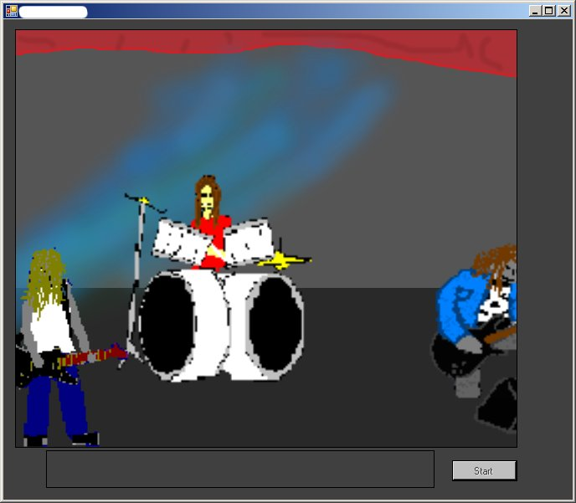

This is a music video of Metallica playing at a rock concert. Multiple images are used to make the performance feel real. Multiple images include band members who appear to really be playing and lights changing in the background. The background scrolls to the left and then to the right focusing on different aspects of the band. Metallica music is playing.

Student 3
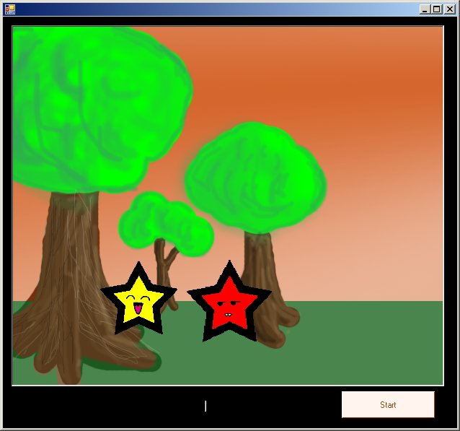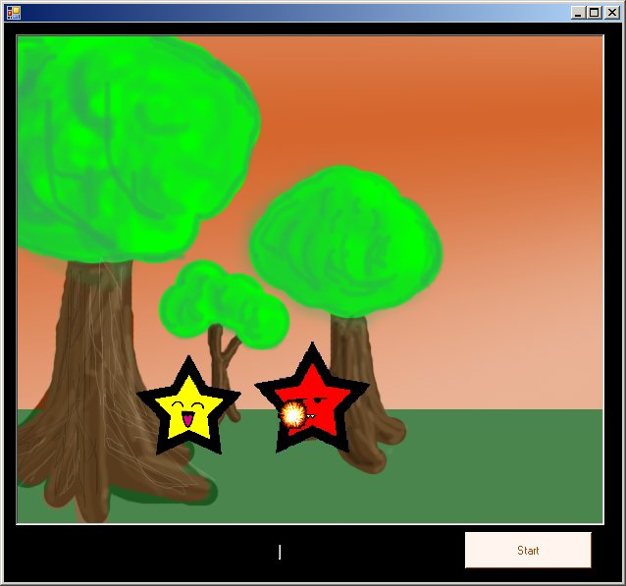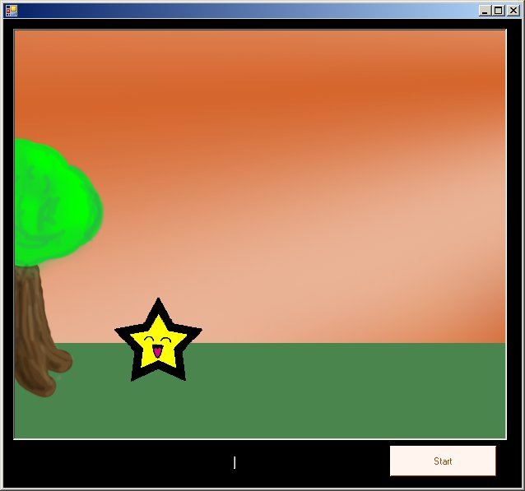

The red and yellow stars fight by shooting fireballs at each other. The red star moves with the arrow keys and the yellow star moves with keys w, a ,s, & d. Shoot fireballs from the yellow star by using the space bar. The background scrolls to the left through a forest scene with bird sounds playing. Collision detection was used to determine if the fireball and red star touch.

Student 4 & Student 7
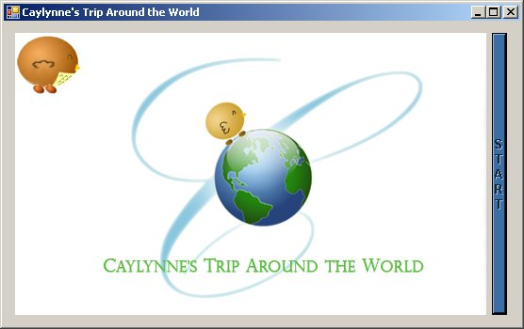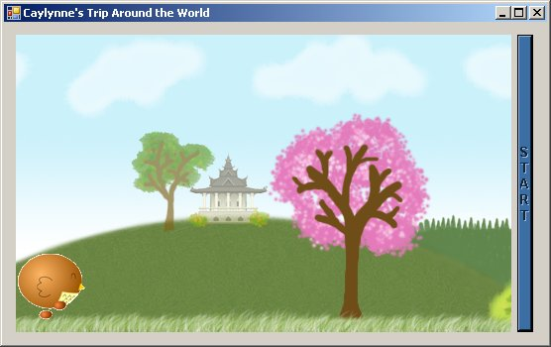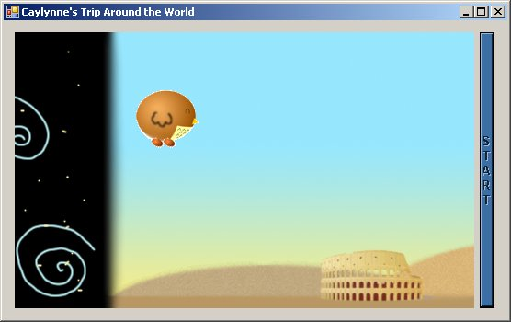

A bird called Caylynne travels around the world visiting exotic locations. Places she visits along the way are Japan, Italy, Egypt, and Hawaii. Each visit includes sights of well known structures, beautiful views, and cultural music. Caylynne has the option of flying through the air or walking along the ground. She flies in 4 directions by using the arrows on the keyboard. The background continuously moves to the left and loops when all the places have been seen so the viewer may experience the sights over and over again.

Student 5 & Student 14:
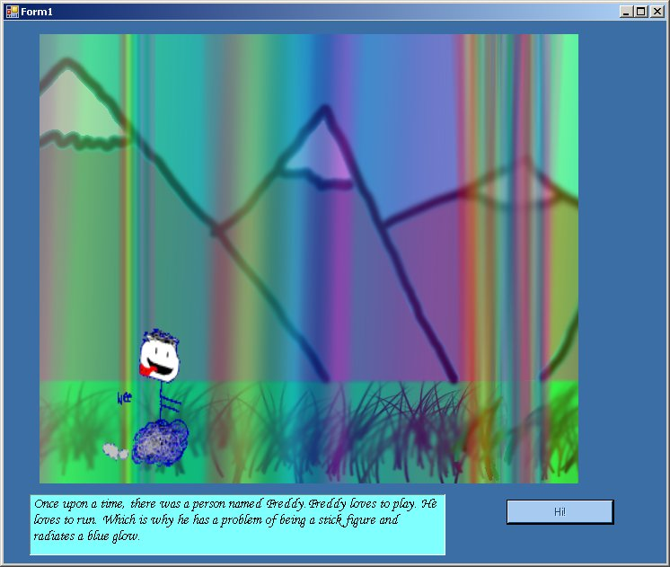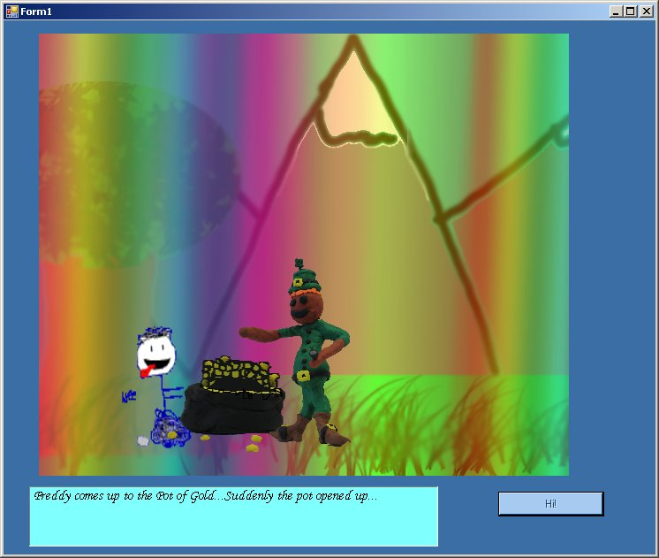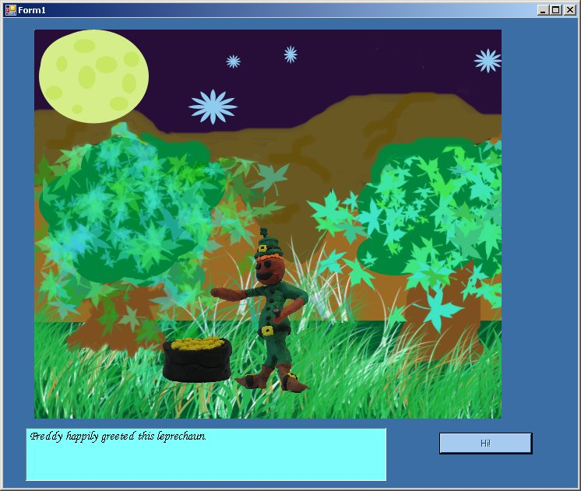

Freddy the stick figure loves to run and play. One day he comes upon a leprechaun and his gold. When Freddy gets too close to the gold he gets a big surprise and is gobbled up. Freddy remains in the same spot on the screen, but appears to be running due to the changing of his character’s image and the background moving to the left. Music and dialog sound waves were used to add comedy and depth to the actions.

Student 6
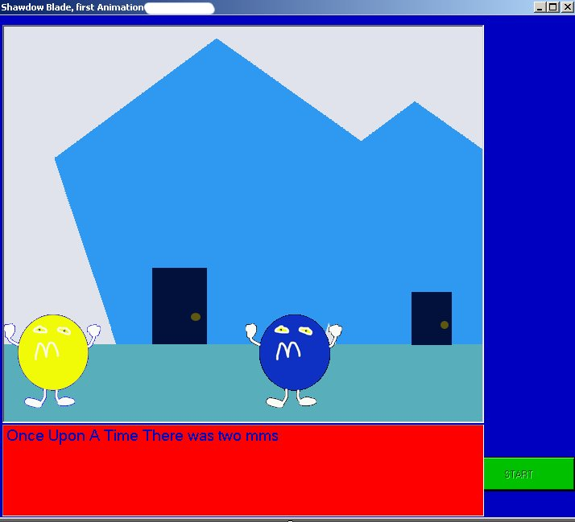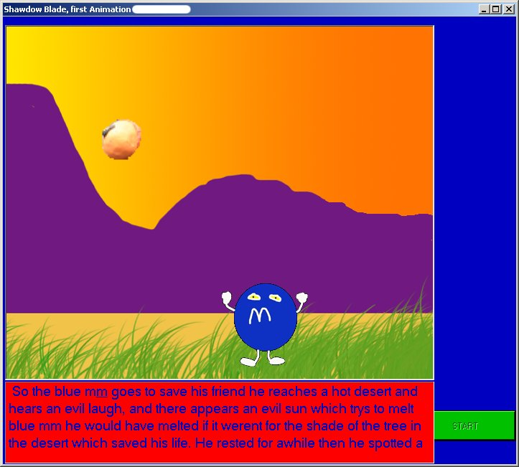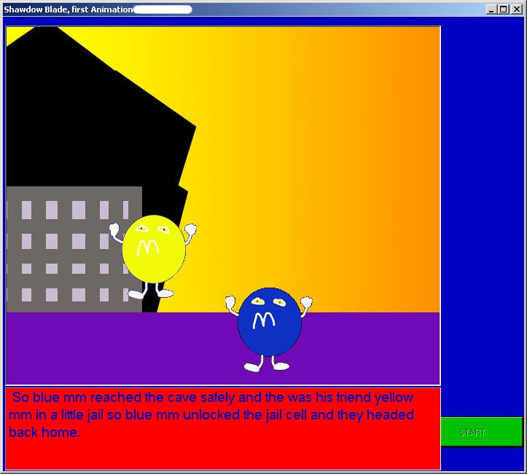

Blue M&M and Yellow M&M are outside playing when their enemy the evil sun snatches up Yellow M&M and takes him away. Blue M&M heads out to rescue his friend facing dangerous terrain and the evil sun. In the end Blue M&M prevails and Yellow M&M is rescued and returned home safely. Blue M&M appears to be walking due to the scenery scrolling left. Music was used to introduce the story and an evil laugh was used for the evil sun. Yellow M&M is able to move in four directions by using the arrow keys and is able to accelerate in speed in four directions by using F1 –F4 keys.

Student 8 & Student 19
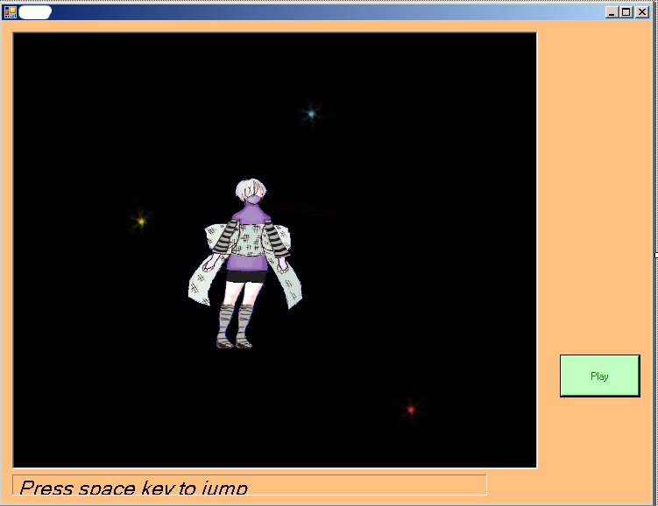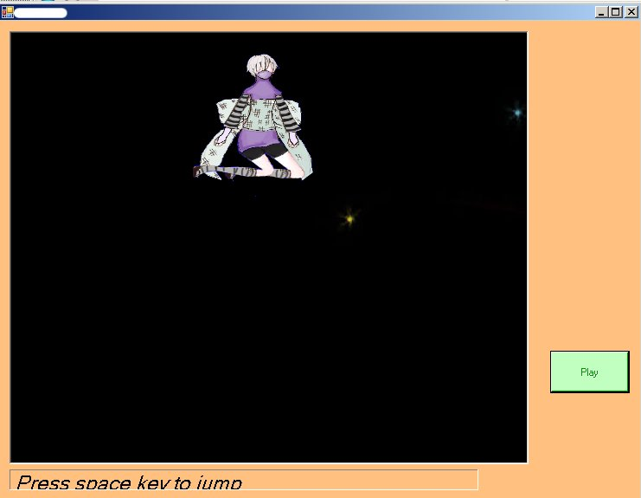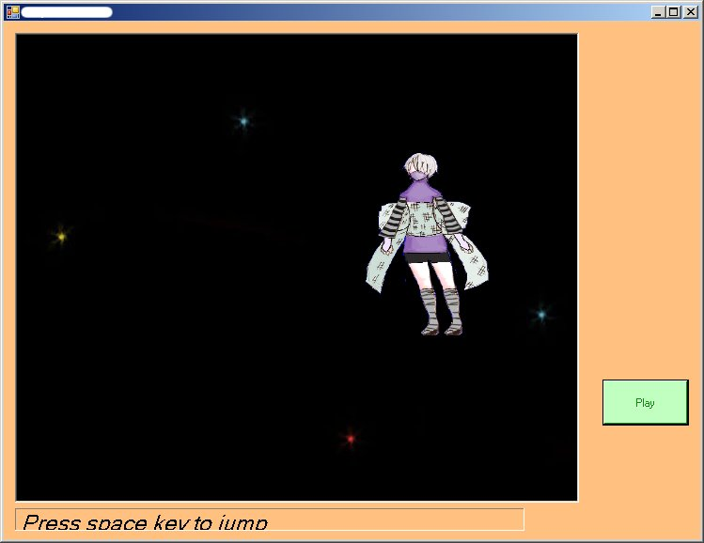

Ninja Girl loves to fly through space. She moves in 4 directions controlled by the arrow keys and jumps when the space bar is pressed. Ninja Girl’s image will flip to face the direction she is moving in and her legs appear to be jumping when the space bar is pressed. Ninja girl was hand drawn and then scanned into Photoshop where coloring and touch-ups were added. The space background continuously scrolls to the left and loops when the end is reached. Music was included.

Student 9
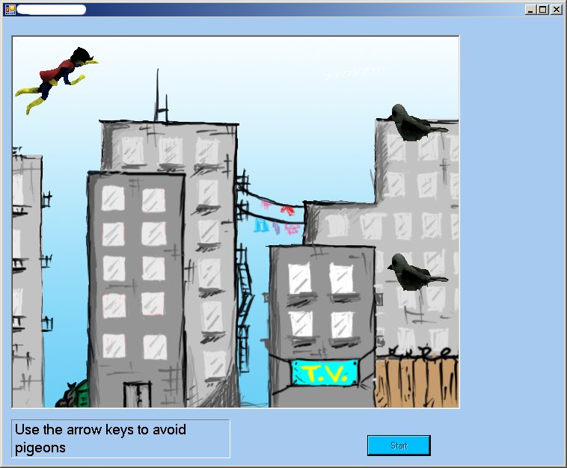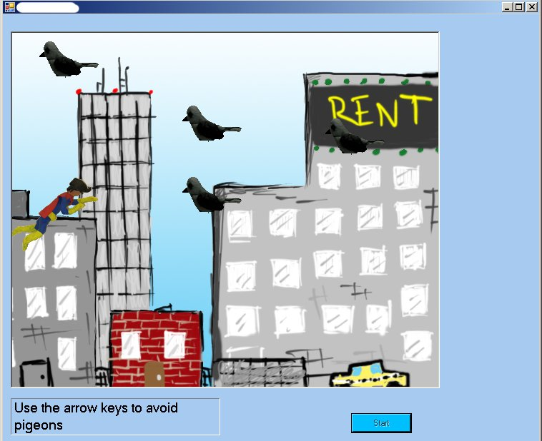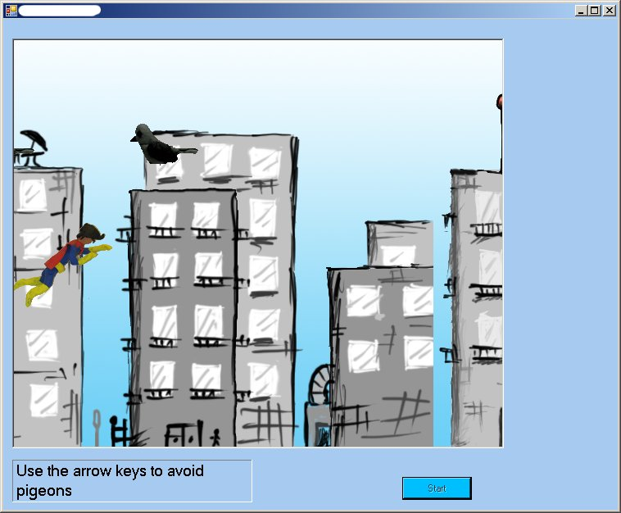

The super hero has his job cut out for him today. The pigeons have joined together to make his job harder. The super hero must fly through the city without hitting a single pigeon. If a pigeon is touched then the game is over. The super hero appears to be flying due to his cape moving and the city background scrolling left. The super hero also moves up and down on the screen by using the arrow keys. The super hero and pigeons are clay animations. Collision detection was used to determine if the super hero and pigeon sprites touch. City sound effects were added.

Student 10 & Student 24
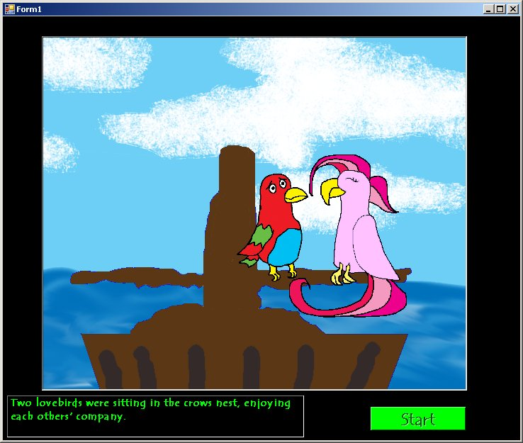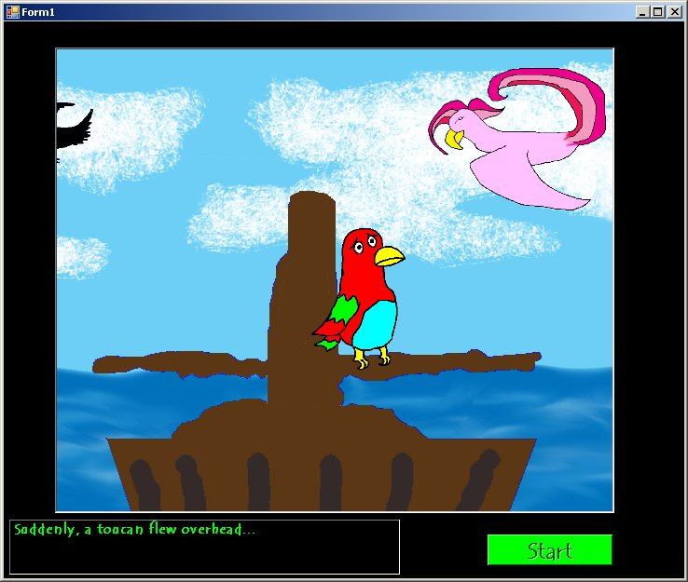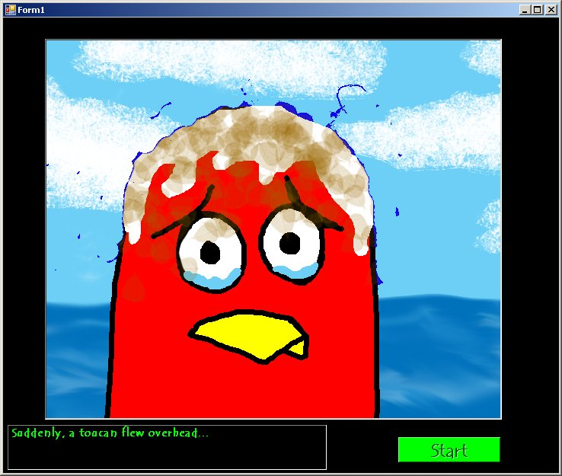

Somewhere in the middle of the ocean is a pirate ship. On the pirate ship are two lovebirds. At least they were lovebirds until the toucan comes along. Animation starts out with a pirate ship that is zoomed in on diagonally until the two love birds are seen in the crow’s nest. The background scrolls to the left to giving the feel of moving water. Music is played in the background to create mood. Timers were used to start new scenes, change music, and to start the animations of the birds flying and the bird dropping falling.

Student 11 & Student 17
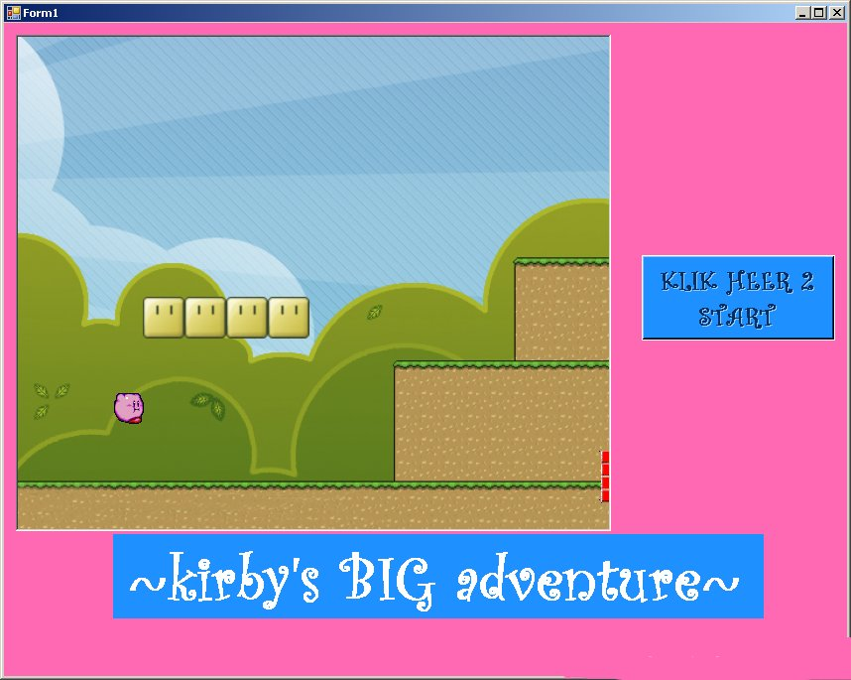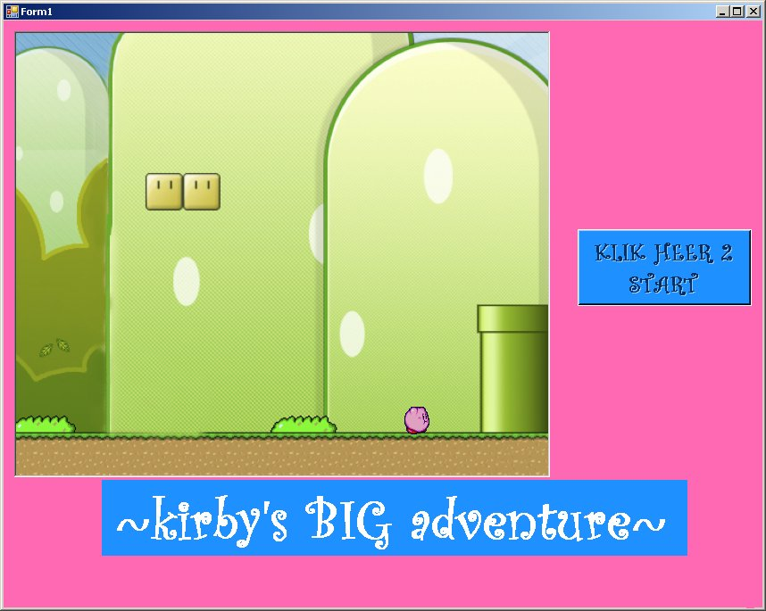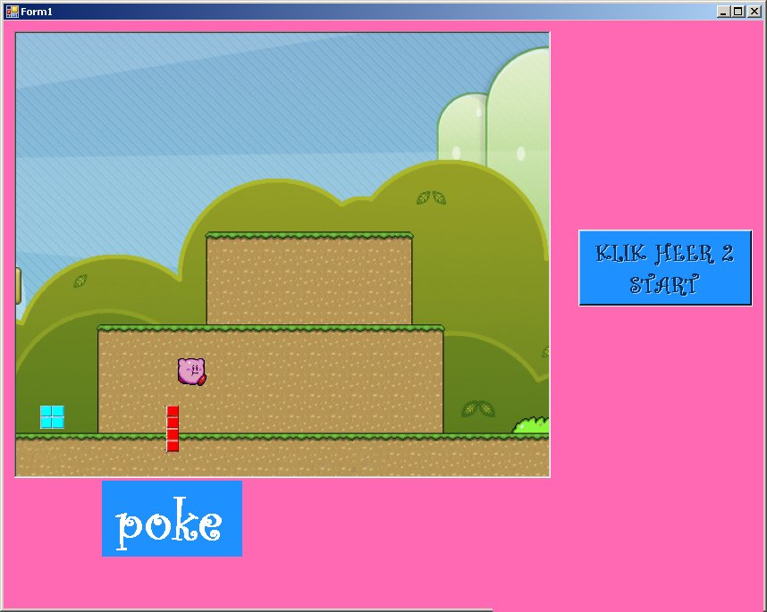

Experience Mario Brothers in a whole new way. Mario Brothers has been changed to have a pink user interface, a fast paced song with a female vocalist, random Tetris block obstacles, and a new character named Kirby. Kirby can move in 4 directions using arrow keys and jumps by using the space bar. Collision detection was added to calculate if Kirby touches the Tetris blocks. If a Tetris block is touched then Poke will appear on the screen.

Student 11
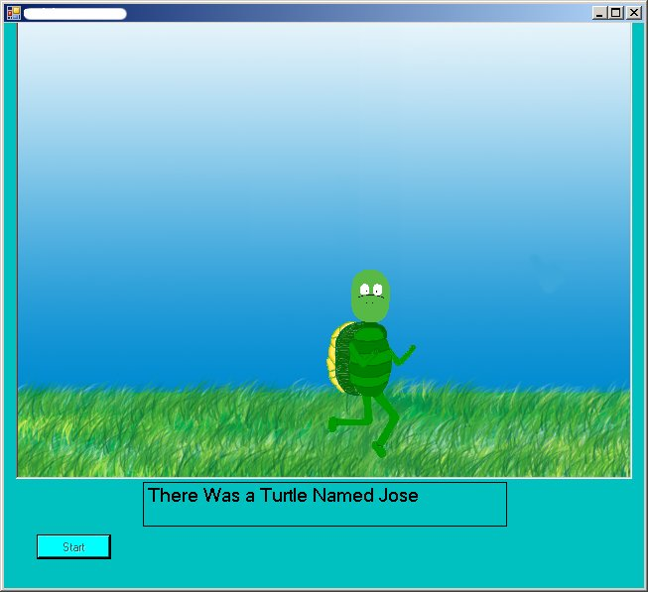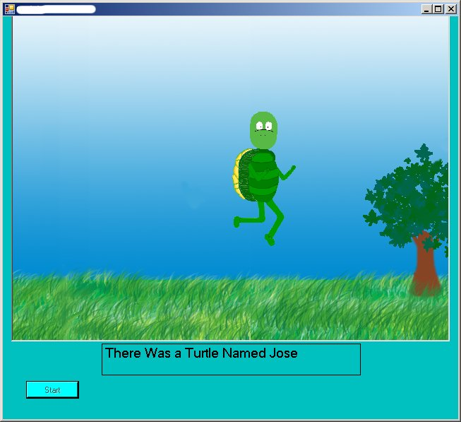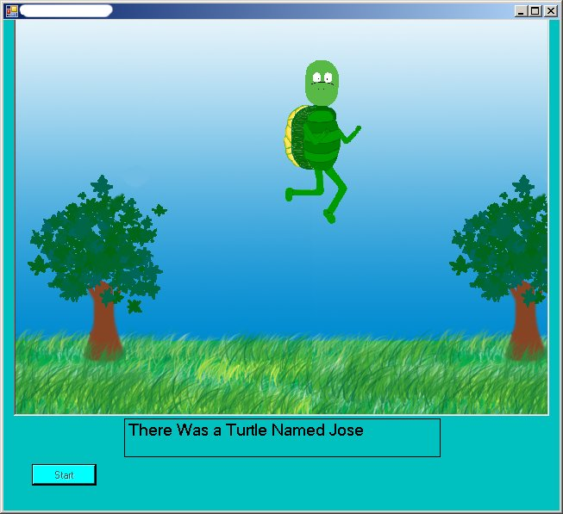

Jose the turtle was walking in the forest when all of a sudden he realized he could fly. Jose is able to move up and down with the arrow keys. The background scrolls to the left and then loops. The Loony Toon’s theme song plays for the listener’s enjoyment.

Student 12
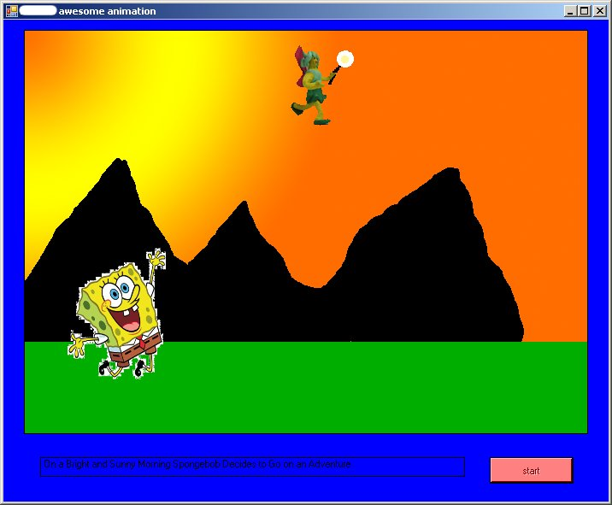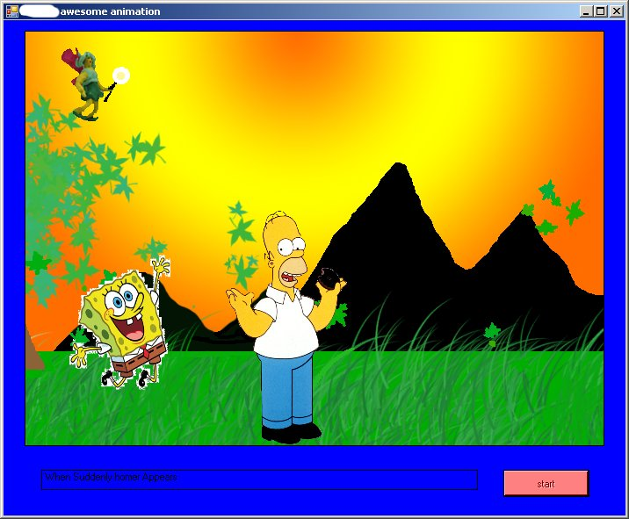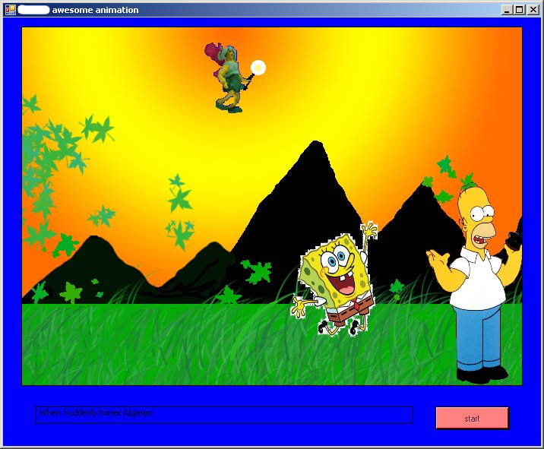

A fairy and Sponge Bob are taking a stroll when they run into their good friend Homer Simpson. The background scene scrolls to the left creating the illusion that the characters are walking and flying. The Fairy can move in four directions with the arrow keys. Sponge Bob and Homer move with keys A, D, and X. Piano music plays lightly.

Student 13 & Student 21
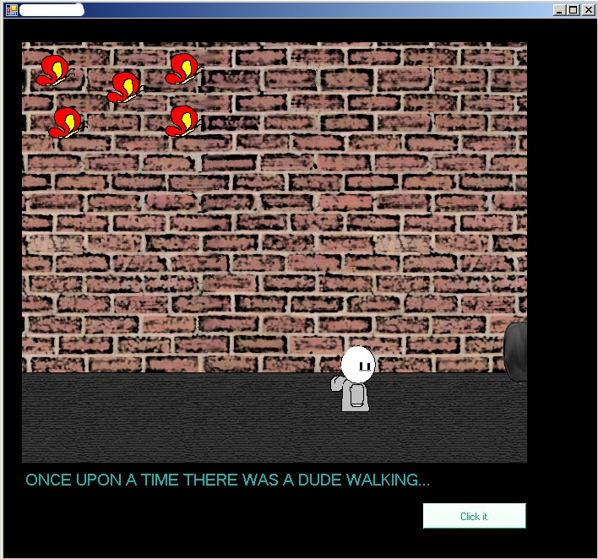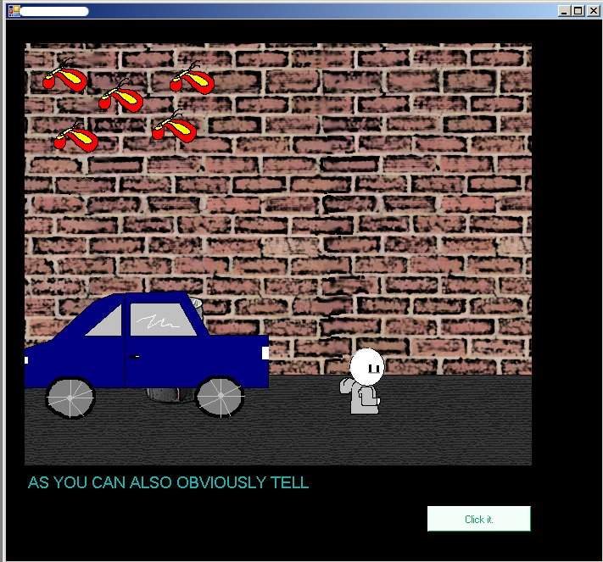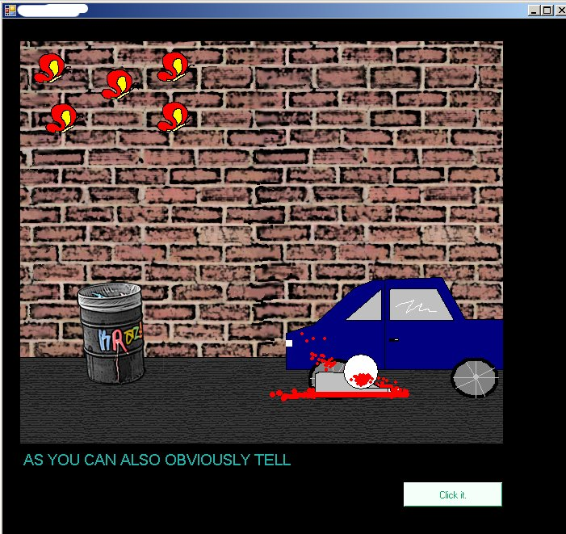

A dude is walking down the street being followed by 5 butterflies. Along comes a car and he dies. To animate the man walking the arms change position and the background scrolls to the left. The car moves across the screen to the right. The butterflies look like they are flapping their wings. A timer was used to change the animation of the dude dying. Pink panther music is playing throughout the whole walking portion of the animation followed by the screeching of a car, a crash, and then sad music when the dude dies.

Student 15
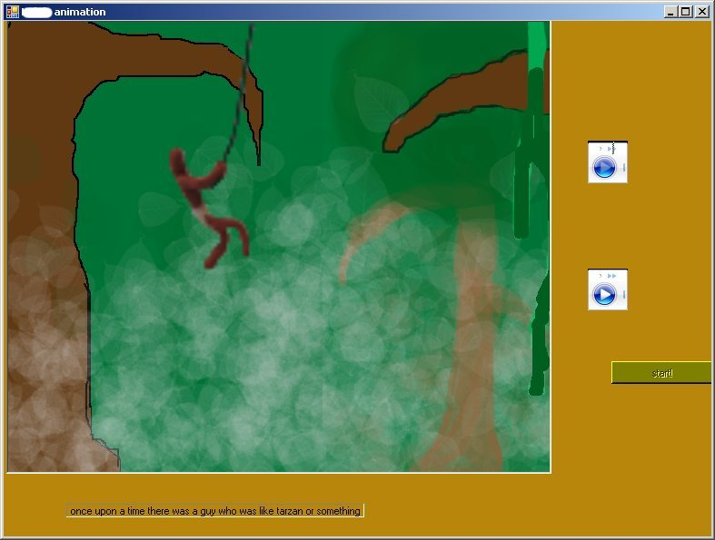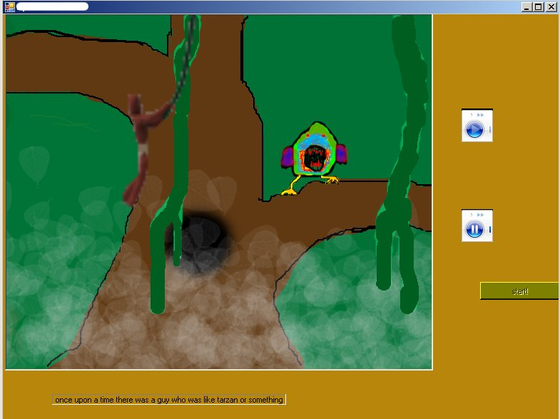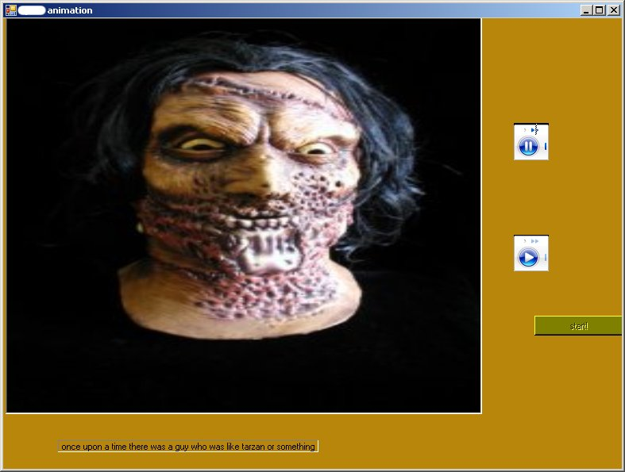

A man like Tarzan is swinging on a vine through the jungle. The scene changes to the man’s face and a loud scream occurs. Jungle noises are played while the man swings on the vine to add realism. The animation of the man and the vine changed to make the swinging appear more realistic and the background moves to the left.

Student 16
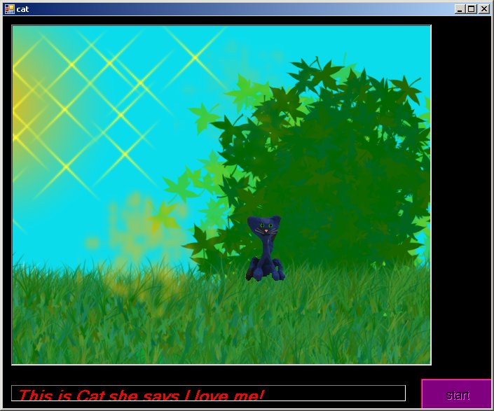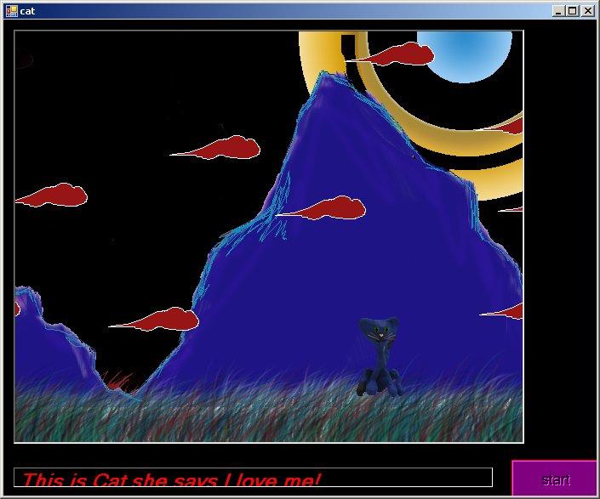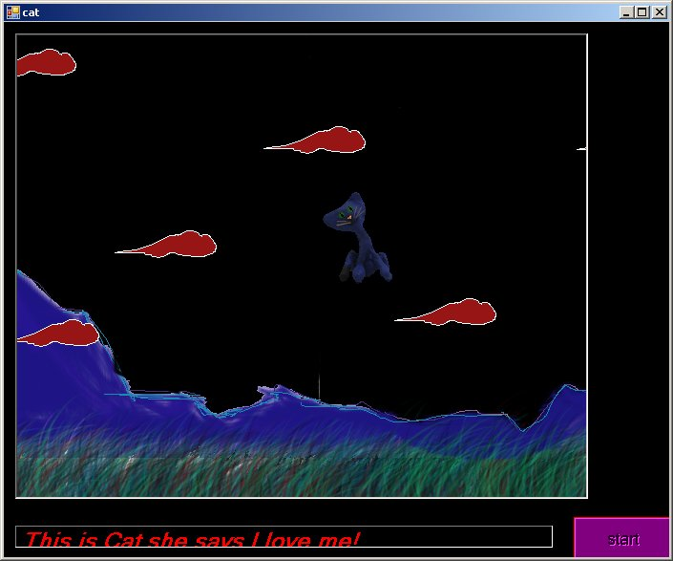

A cat is walking through the forest on a bright and sunny day. All of a sudden she is transported to a mountain hill side where a meteor shower is happening. That is when the cat learns that she is weightless. The cat uses her weightlessness to dodge meteors. The cat can move in 4 directions using the arrow keys. The background scrolls to the left and the cat has multiple images to make it appear like she is walking. The cat is a clay animation. Pink Panther music is used to add depth to the animation.

Student 18 & Student 23
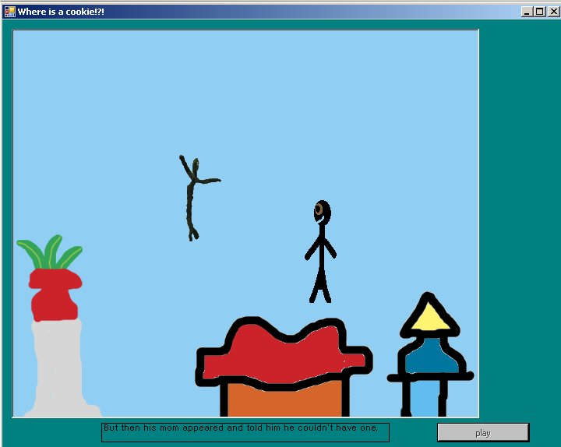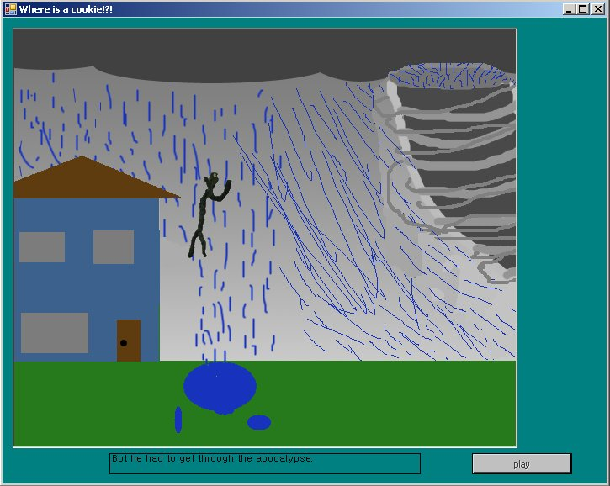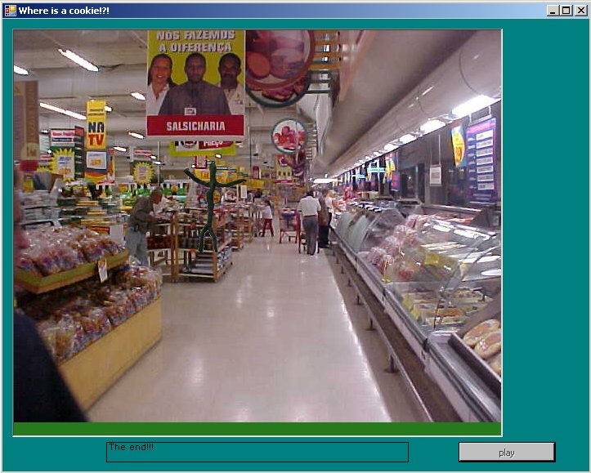

A boy wants a cookie really bad. When he asks his Mom, she tells him, “No”. The boy thinks up another way to obtain the cookie but he has to go through the apocalypse. Finally the boy makes it through the apocalypse and is able to buy a cookie at the Mexican grocery store. The boy moves in four directions by using the arrow keys. The background scrolls to the left making it feel like the boy is walking. Storm noises are used to emphasis the apocalypse.

Student 20
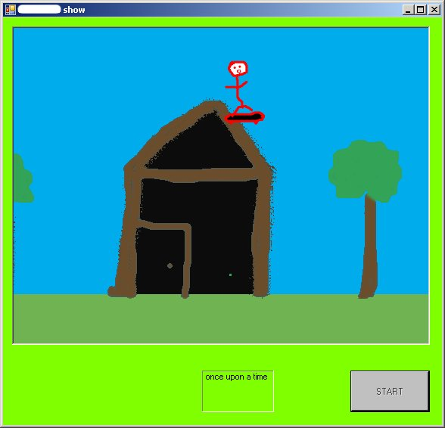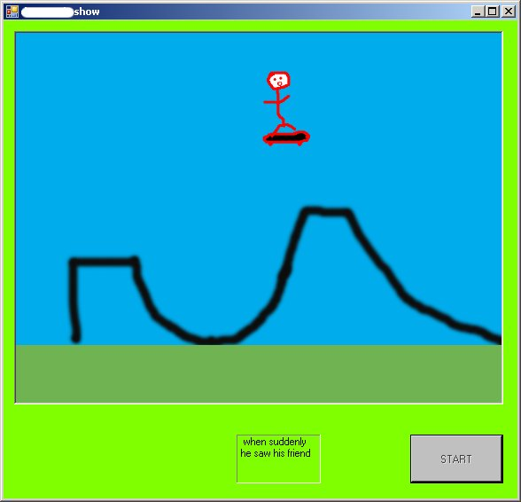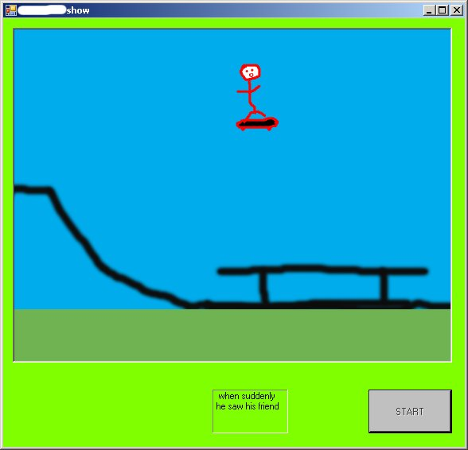

A skate boarder takes to the skies. He flies over a skate ramp, a house, trees, as well as other obstacles below. The background scrolls to the left and then loops. Code has been written to move a character, but was not finished being connected to the skater. Plans were also in the works for the skate boarder’s friend to appear as can be seen in the text on the screen.

Student 22
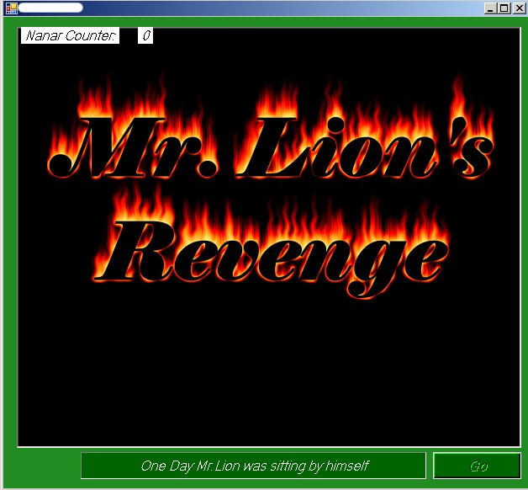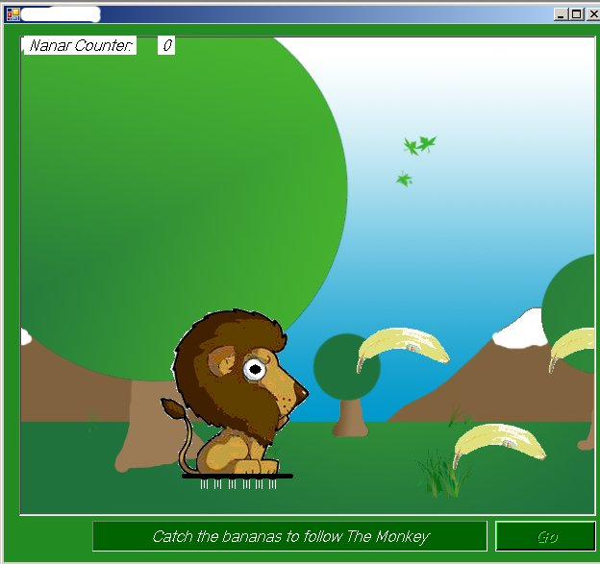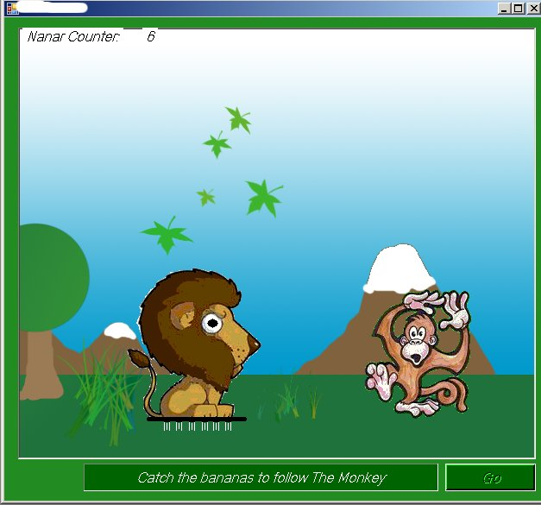

Mr. Lion was being teased by a monkey so now he is out for revenge. Mr. Lion follows the banana trail to the monkey. The user can control Mr. Lion with the arrow keys in 4 directions. The background scrolls to the left. The user can pick up bananas along the way to the monkey to gain points. A counter is on the top left hand side of the screen. The R key can be pressed to make the lion roar. Collision detection is used to determine if Mr. Lion touches the bananas or the monkey. Music is played to add depth to the game.

